**DATASHEET**

**TK2560**

Embedded Systems Training Kit

Last Revision: 15/09/21

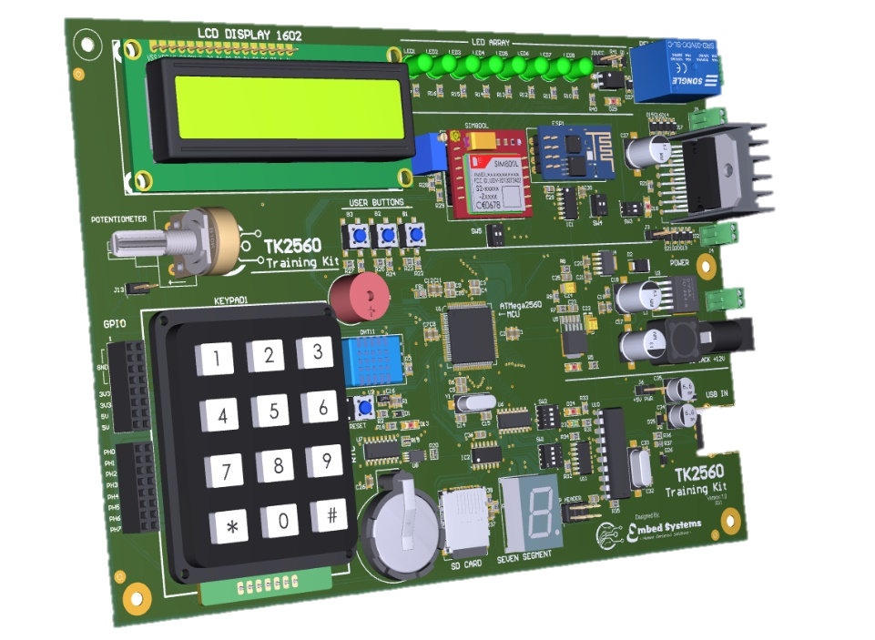

OVERVIEW

TK2560 is an embedded systems training kit. It’s based on ATMega256 microcontroller from Microchip. TK2560 is designed to provide most peripherals and interfaces to enable its user to learn and implement code for several 8-bit microcontroller features and peripherals. It has several modules included and it also has an on-board programmer therefore the user needs no external programmer.

It’s designed for all kinds of users of all levels: it can be used by beginners and students who want to explore microcontroller programming, it can be used by professionals who wish prototype or test a specific feature and it can also be used as a reference design by a product developer who is implementing a particular solution using a similar microcontroller.

FEATURES:

* ATMega2560 Microcontroller
* 16x2 Character LCD Display
* 1 Digit Seven Segment Display
* 8 LEDs Array
* 1 Buzzer
* 1 Opto-coupled solenoid relay
* 4x3 Keypad matrix
* 3 User tactile switches
* DHT11 Temperature sensor
* Power connector (12V)
* 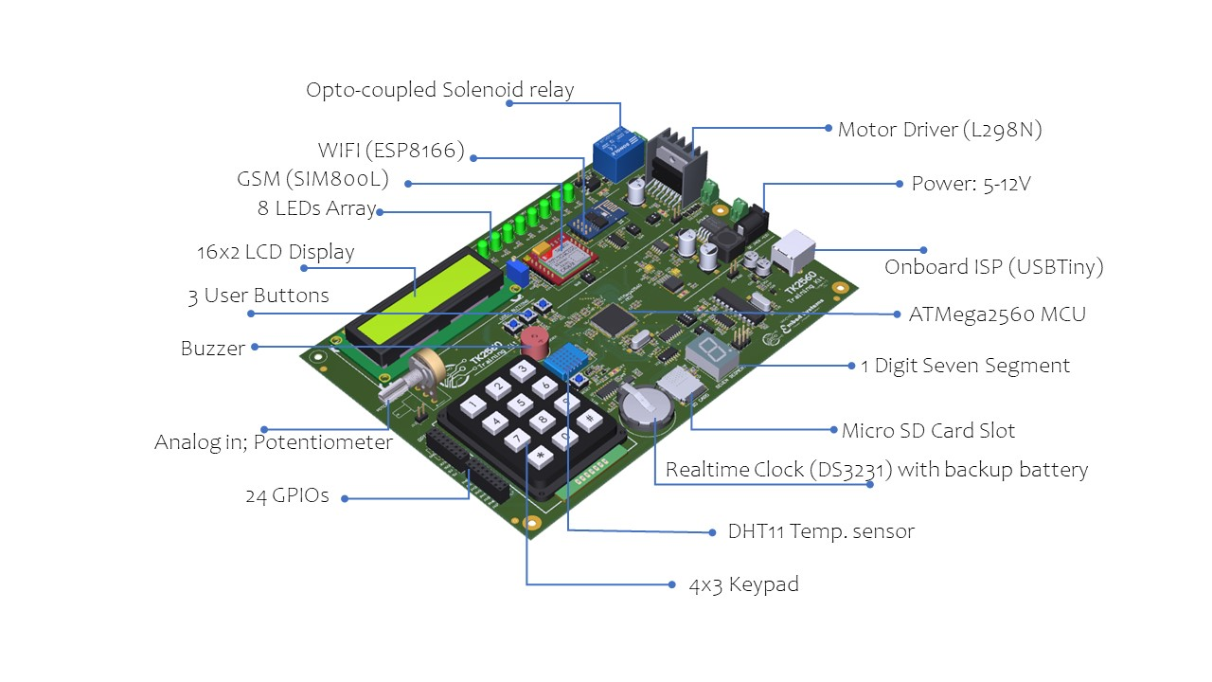Realtime clock (DS3231) with backup battery
* EEPROM with I2C interface
* WIFI module (ESP8266) using UART interface
* GSM module (SIM800L)
* MicroSD card slot using SPI interface
* 1 Motor driver (L298N)
* Onboard ISP (USBTiny)
* 24 GPIOs
* Potentiometer
* Power pins (5V, 3.3V)